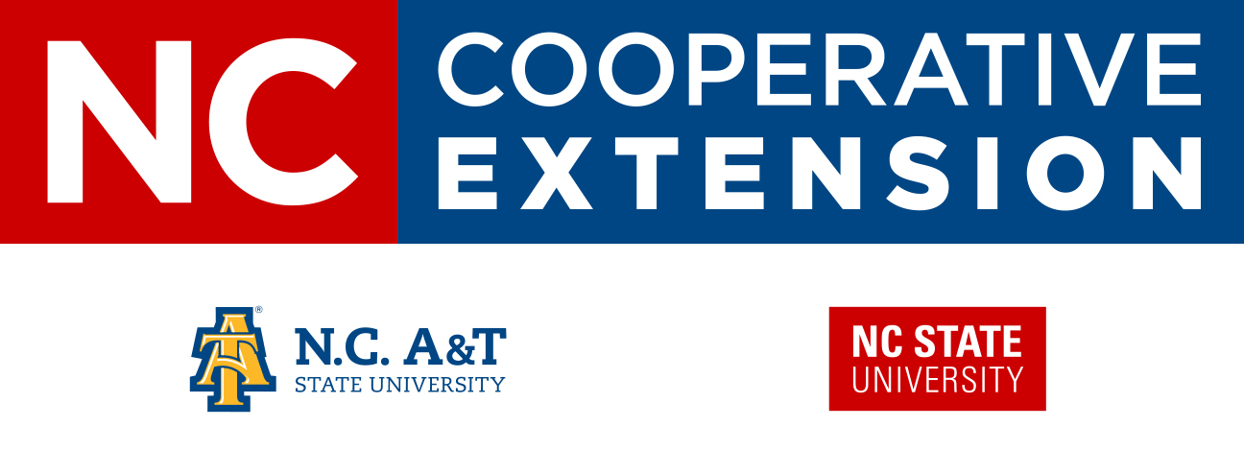
NC State University and N.C. A&T State University are collectively committed to positive action to secure equal opportunity and prohibit discrimination and harassment regardless of race, color, national origin, religion, political beliefs, family and marital status, sex, age, veteran status, sexual identity, sexual orientation, genetic information, or disability. NC State, N.C. A&T, U.S. Department of Agriculture, and local governments cooperating
-------------------------------------

Farm Business Meeting

-------------------------------------
March 27th, 2019
9 am- 1 pm
525 NC Hwy 65, Reidsville NC 27320
Come and join us for an informational farm business meeting for farms of all kinds and sizes!  Please RSVP by March 22nd, 2019 to reserve your spot!  Please contact Cooperative Extension Agents Kathryn Holmes or Abby Whitaker at (336)-342-8230 or Anna-Beth Williams at (336)-641-2400 with any questions or concerns. | Owen Peele  Farmer, Pamlico County “Farm Transitions”  “Haulin’ Ag”  NC Farm Bureau  Potential Session on Marketing your farm!

