North Carolina 4-H
Project Record Report Form
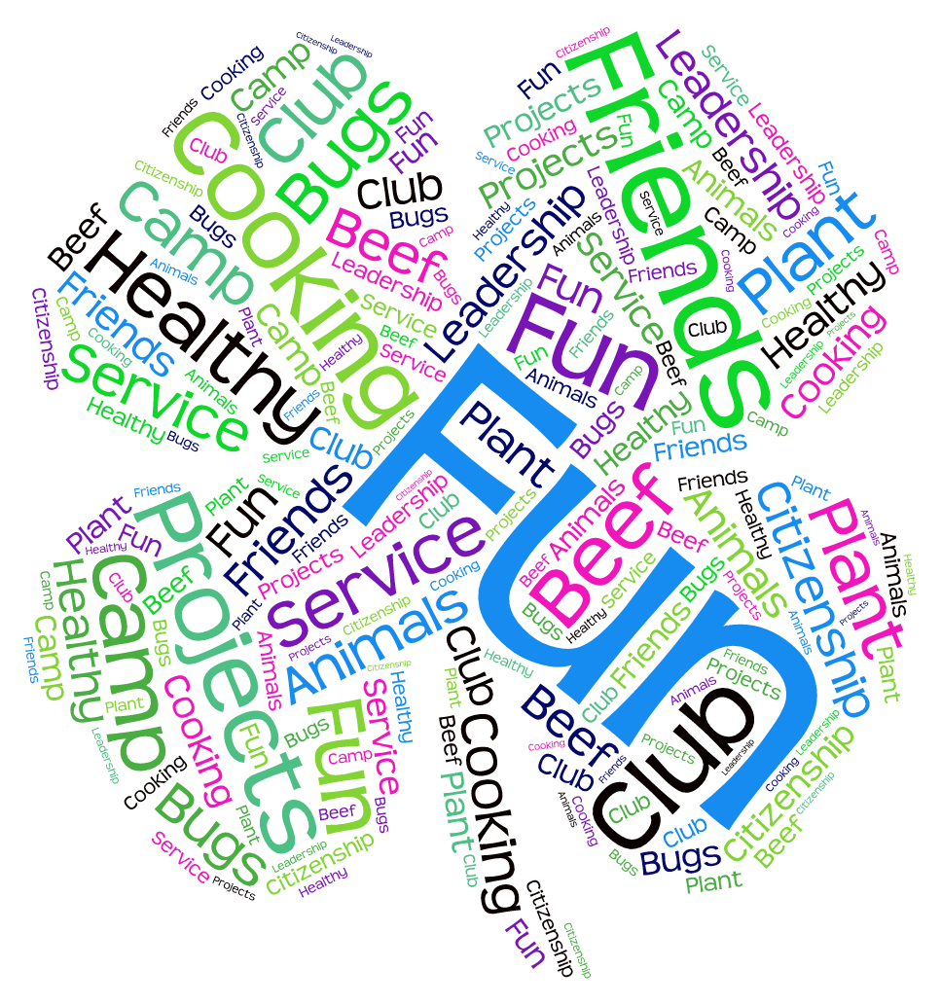
Age Categories:
8-10, 11-12

North Carolina 4-H Project Record Guidelines

- Each 4-H member should complete their 4-H Project Record to the best of their ability and turn it into their county 4-H agent by the county due date.

- Project work should be reported for one year. You may add additional pages to the report form in sections 1,3,4,5,6,7. All information should only be listed once in the report form. This means you may have to choose the BEST place to report information.

- Some of your goals and accomplishments may be shared with family and/or 4-H club members, but this project should be your OWN work.

- All materials are property of North Carolina 4-H and may be used to showcase 4-H work but will not contain your personal information.

Guidelines For Completing Your Record Book:

- Use this form as a guide for completing your record book. If you choose to type your record, feel free to use a word processing program. We do ask that you list the Section Number and Title at the top of the page.

- In the upper right hand corner of the outside cover, please include the following information: Name, County, District, Project Record Category, and Age Category.

- Place your Project Record in a 3 prong report folder (No 3 ring binders please).

- Please print legibly or type using Arial or Times New Roman font in size 12 ONLY. See link below for the form to download:

http://www.nc4h.org/youth/4-h-awards-incentives-programs

Guidelines

Your 4-H Project Record should have all 7 sections of the book in consecutive order and should only include things from THIS YEAR (January 1 – December 31).

Section 1 – Personal Information and 4-H & You
Please be sure to complete all of the information requested on this page. Do not forget to list your Project Record Category. Make sure the appropriate people sign your Project Record.

Section 2 – My 4-H Story
Tell us your 4-H story! Your story should be no more than 4 pages. It can be typewritten or printed neatly. It should include your entire 4-H experience for this year. Introduce yourself to the judge. See specifics in Section 2.

Section 3 – 4-H Project Focus
We "learn by doing" in 4-H. List the specific things you learned and did in this project area this year. Project work is from January – December. List knowledge and skills gained as well as the things you learned how to do. Include dates and levels of participation. Please list the most important presentations, talks, exhibits, radio, TV, newspaper articles, tours, camps, judging events, workshops, and any other learning experiences in which you have participated related to your project. You should only include 4-H work completed in one program year.

Section 4 – Leadership/Citizenship/Community Service
In this section, please make a list of the things you have done involving citizenship, community service, leadership, and other projects and events. If you are listing non 4-H activities, please list only those for which 4-H has helped you prepare. If your 4-H project focus is on Leadership, Citizenship or Community Service you may write “See Section 3” as your answer in this section or use it to continue adding project work for Section 3. Leadership includes holding offices and serving on committees. It also can include teaching workshops, volunteering at 4-H Day Camps, giving a club program, organizing events and meetings, and recruiting new members. Community service activities might include fundraising for a community organization or assisting with the Fire Department raffle. List the number of hours you volunteered and who benefited from your volunteer service. You might also begin to learn about citizenship by going to county commissioners or town council meetings or writing your legislative representative.

Section 5 –Awards and Recognition
List certificates, ribbons and other awards you have won in this year. Separate out your 4-H awards and your Non 4-H Awards. Specify whether they were National, Regional, State, District, County or Club awards.

Section 6 – 4-H Photos and Supporting Materials
Include up to six 4-H scrapbook pages, which may include pictures (with descriptive captions that explains what is going on in the photo), news clippings, letters, certificates, poems, teaching tools, short stories, digital media, etc.

Section 7– 4-H Goal Setting for the Next Year
In order to get the most out of your 4-H Project experiences, you must be actively involved in developing what your 4-H projects will be, set your own goals and making decisions on when and what you will do to accomplish their goals. Goals represent the direction of your destination. When your goals are well written and explained, it help members, parents, leaders and agents know exactly the direction you want for your 4-H project. Your goals should have the following parts: “I want”; Action; Results; and a Timetable. You will develop the goals for the next year (the year coming up, after you complete this book) in your 4-H projects.

ACTION: How you will do something?
RESULTS: What you are going to do?
TIMETABLE: When are you going to do it?

Questions to think about as you develop your goals for the next year in 4-H:
What are some things I really like to do?
How good am I already at these things?
How much do I know about this already?
Is there one thing I’d like to learn more about or learn to do better?
Are there completely new things that I want to learn or do?

A goal is:
- the point you strive to reach
- completed by a designated time
- short term or long term
- an ideal to strive towards, sometimes so far up, it is impossible to reach from the point you are now. By trying and working hard, you can obtain that goal.

Examples of How to Write Your Goals:

ACTION RESULTS TIMETABLE
I want to learn how to eat healthier by December.
I want to give a 4-H presentation at DAD by June.
I want to train my do to sit and stay before summer is over.


North Carolina 4-H Project Record
For More Information contact:
Shannon McCollum
Extension 4-H Associate
shannon_mccollum@ncsu.edu
(919)515-8486
www.nc4h.org

A Message to 4-H’ers:
Introduction
Records are important because they show what you have learned and the skills you have learned as a 4-H’er! If you keep records every year, you will be able to look back at them and see how you have grown. The information you put in your 4-H records will be very helpful for you as you fill out other forms in your life, such as 4-H Portfolios, resumes, job applications, and college applications.
- This form is designed to help you keep records and other supporting materials in an orderly manner.
- Record keeping is an important part of every 4-H educational project.
- Many awards, educational trips, and college scholarships are given to club members based on their records and project work.
- Records show your 4-H growth. You may include 4-H work completed in one program year (January 1 – December 31).
- Do not alter the basic format of this book.
- You may hand write neatly or type in size 12 Arial or Times New Roman font.

Your 4-H Project Record should contain the following sections:
Section 1 Personal Information and 4-H & You
Section 2 4-H Story
Section 3 4-H Project Focus
Section 4 Leadership/Citizenship/Community Service
Section 5 Awards and Recognition
Section 6 4-H Photos or Supporting Materials
Section 7 4-H Goals Setting

SECTION 1: Personal Information

County You Participate In 4-H: ______________ Program Year: _______

4-H Project Record Category in which you are entering: _________________________________

Competition Category: 8 thru 10 years old 11 thru 12 years old
(age as of Jan. 1 for the project reporting year)

Number of years in the above program area: _____ Years in 4-H: _____

Name: __________ __________ __________ Male Female
(first) (middle) (last)

Name you want used in publicity: ______________________________________
(please print)

Home Mailing Address: ______________________________________

City: ______________________ State: ________ Zip Code: __________

Primary Telephone Number (include area code): ______________________________________

Date and Year of Birth: __________ Age as of January 1: __________
(age as of Jan. 1 for the project reporting year)
Names of parents or guardians: _______________________________________________

Name of your 4-H club or group: _________________ 4-H’ers Primary email address if applicable: ______________

Name of School: __________________ Grade in School: __________________

Have you won District Gold in this age category previously. If so: What year_______. What District: _________

STATEMENT BY 4-H MEMBER

I give North Carolina 4-H permission to use my record as a sample, after identifying information has been removed, and allow North Carolina 4-H to use my Digital Media if any is provided to use for 4-H Marketing opportunities. I also understand that North Carolina 4-H will contact me before any of my information is shared.

I have personally prepared this report and certify that it accurately reflects my work:

Date: ____________, 20 ___________ Signature of 4-H Member: _____________________________________

APPROVAL OF THIS REPORT

We have reviewed this report and believe it to be correct:

Date: _______________, 20________ Signed: ____________________________________________________
(Parent or guardian)
Date: _______________, 20________ Signed: ____________________________________________________
(Local 4-H Leader)
Date: _______________, 20________ Signed: ____________________________________________________
(County Extension Agent)

4-H & YOU!
Answer questions on separate paper if needed.

Looking back over the past year in 4-H:

1. What was your favorite thing you did in 4-H this year and why?

2. Who is your role model in 4-H? Why?

3. What was the most important thing you have learned during the past year in 4-H?

Looking to the future:

4. If you were in charge of 4-H, how would you make it better? In your:

Club:

County:

District:

SECTION 2
My 4-H Story
(Place your 4-H Story behind this page)


Tell us your 4-H story! Your story is limited to no more than four (4) pages typed or handwritten. Your story should include all of your 4-H projects for this year.

Here are some things you COULD include in your story:

Introduce yourself and include any information you choose to share about your interests, family, hobbies etc. If you were given two minutes to tell someone about yourself, what would you say?

Describe how 4-H has made a difference in your life.

How did the project you are completing in this Project Record help you grow?

Who has helped you in your 4-H journey?

How has your 4-H participation helped others?

What are your goals in life?

Summarize your experiences in 4-H.

Sections 3-5 of this record book can help you.
Program Year:_____

SECTION 3
4-H Project Focus

(Name of 4-H Project)

We “learn by doing” in 4-H. List the specific things you learned and did in this project area during the past year. List both things that you learned and skills that you gained. Please list the most important presentations, talks, exhibits, camps, judging events, workshops, or any other learning experiences in which you have participated related to your project. Include dates and level of participation. Please list the work you have done this year (from January – December) using a bullet statement, list, and/or chart.

What did you do in this project this year and when? | What did you learn? | Level
Sample: I showed 5 goats in the NC State Fair in October. | Sample: I learned the parts of a goat, how to groom a goat, and how to place the goat’s feet in a show. | S
When completing your project record or portfolio, you may delete examples above.

(Attach pages here)

Did you spend or make any money on your project?
How much did you spend? How much did you make?

Program Year:_____
SECTION 4
Leadership/Citizenship/Community Service


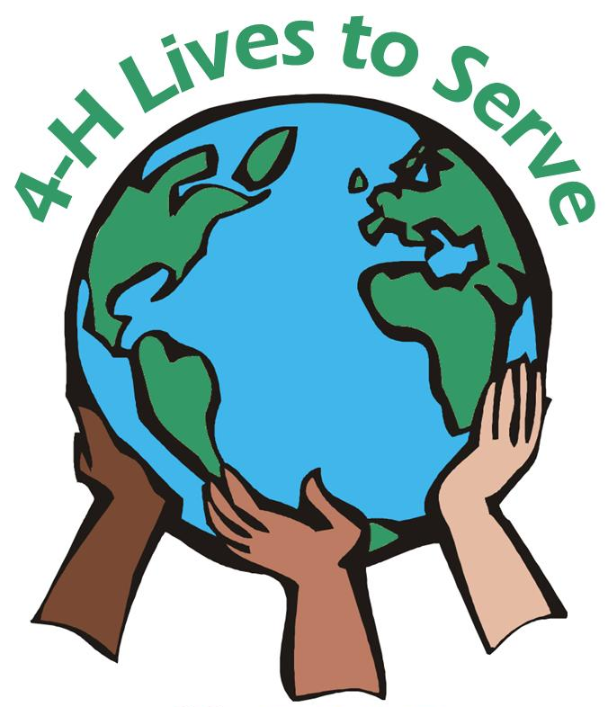
In this section, please make a list of the things you have done involving citizenship, community service, and leadership. If you are listing non 4-H activities, please list only those for which 4-H has helped you prepare. If your 4-H project focus is on Leadership, Citizenship or Community Service you may write “See Section 3” as your answer in this section or use it to continue adding project work for Section 3. Leadership includes holding offices and serving on committees. Community service activities might include fundraising for a community organization or assisting with the Fire Department raffle. List the number of hours you volunteered and who did you help. You might also begin to learn about citizenship by going to county commissioners or town council meetings, and learning flag etiquette.

- List ways you have been a leader and/or have learned
about leadership.
- Please denote 4-H activities with an asterisk.
- If you are listing non 4-H activities, please list only those for which 4-H has helped you prepare.
- Before you list the activity put and L for Leadership, C for Citizenship and CS for Community Service.

Example:
Activity - L=Leadership, C=Citizenship, CS=Community Service | Accomplishment | Level
L - Led the 4-H pledge | 15 members | C
L - Led an icebreaker activity at County Council | Led 12 4-H'ers in the Human Knot/1 hour | C
C - Recited the 4-H pledge |  | C
C - Learned about each of the club officer positions |  | C
CS - Donated 6 canned goods for Food for Families Food Drive | 1 hour, 6 items | D
CS - Wrote letters to soldiers | 3 hours, 20 letters | N

(Attach pages here)

*Level = L - Local, C - County, D - District, S - State, R - Regional, N - National

Program Year:_____
SECTION 5
Awards and Recognition

List all the awards, honors, and recognitions you have received including contests, trips, certificates, ribbons, etc. Specify whether they were National, Regional, State, District, County, or Club awards.

Experiences should be divided between project specific awards that related to this Project Record area, other 4-H awards and non-4-H awards. List your Project specific awards first then follow with other awards and then non-4-H awards.

If you have not received awards in a specific section, just state “No Awards Received”.

4-H Project Awards (Section 3 awards)
Award/Recognition | For What Received | Level
Sample: Gold Medal | Sample: Electric Portfolio | D,S
Sample: Certificate | Sample: Duke/Progress County Delegate | C
When completing your project record or portfolio, you may delete examples above.

Other 4-H Awards
Award/Recognition | For What Received | Level
Sample: Certificate of Participation | Sample: Attendance State 4-H Marsh Maneuvers | S
Sample: Certificate & Blue Ribbon | Sample: Area Commodity Ambassador
When completing your project record or portfolio, you may delete examples above.

Non 4-H Awards & Recognition
Type of Award/Recognition | For What Received
Sample: Plaque – 1st place | Sample: Community Beautification poster contest
When completing your project record or portfolio, you may delete examples above.

(Attach pages here)
*Level = L - Local, C - County, D - District, S - State, R - Regional, N - National

Program Year:_____
SECTION 6
4-H Photos and Supporting Materials

- The majority of this section should be about this specific project.
- Also include a small portion on your other 4-H projects and activities.
- There is a six-page limit.
- This can include pictures (with captions), drawings, news clippings, letters, certificates, poems, teaching tools, short stories etc.
- Please do not attach any item thicker than 1/8 of an inch.
- The use of clear non-glare protective sheets is optional.

Digital media should be no more than two minutes long. Please use YouTube to upload your videos, as this is our preferred method. Also, please note that all videos must have closed caption incorporated into it. This is a requirement. All digital media will count as one page.

(Attach pages here)

SECTION 7 Program Year:_____
4-H Goal Setting


What would you like to do next year in 4-H (after you submit this project)? On a separate piece of paper, please use the guide below to plan your 4-H goals for next year. Include goals for your entire 4-H year as well as goals for this specific project. There is no page limit to this section.

ACTION RESULTS TIMETABLE
I want to learn how to eat healthier by December.
I want to give a 4-H presentation at DAD by June.
I want to train my dog to sit and stay before summer is over.

(Attach pages here)

For More Information

Visit our website: www.nc4h.org

Shannon B. McCollum, Ed.D
Extension 4-H Associate
shannon_mccollum@ncsu.edu
(919)515-8486

North Carolina State University and North Carolina A&T State University commit themselves to positive action to secure equal opportunity regardless of race, color, creed, national origin, religion, sex, age, veteran status or disability. In addition, the two Universities welcome all persons without regard to sexual orientation. North Carolina State University, North Carolina A&T State University, U.S. Department of Agriculture, and local governments cooperating.

